**MFA data for finance website**

1. Netlify address

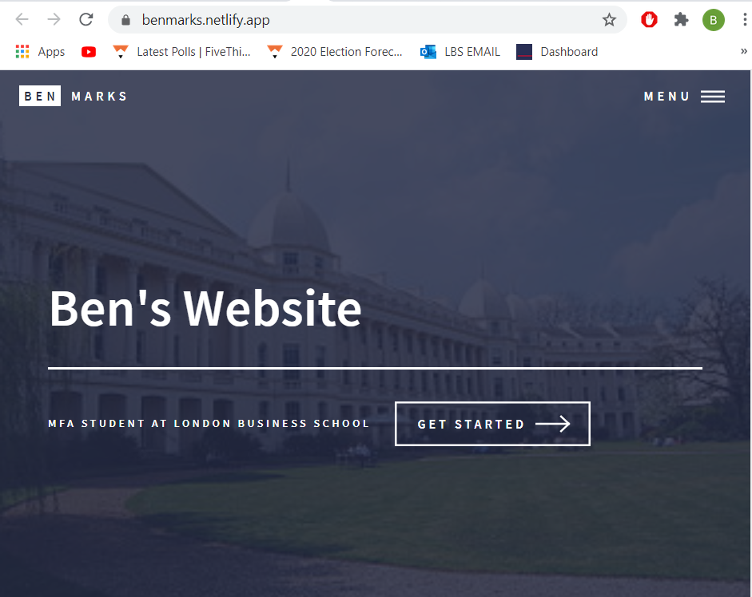

1. Git hub address

**Note: use website 999**

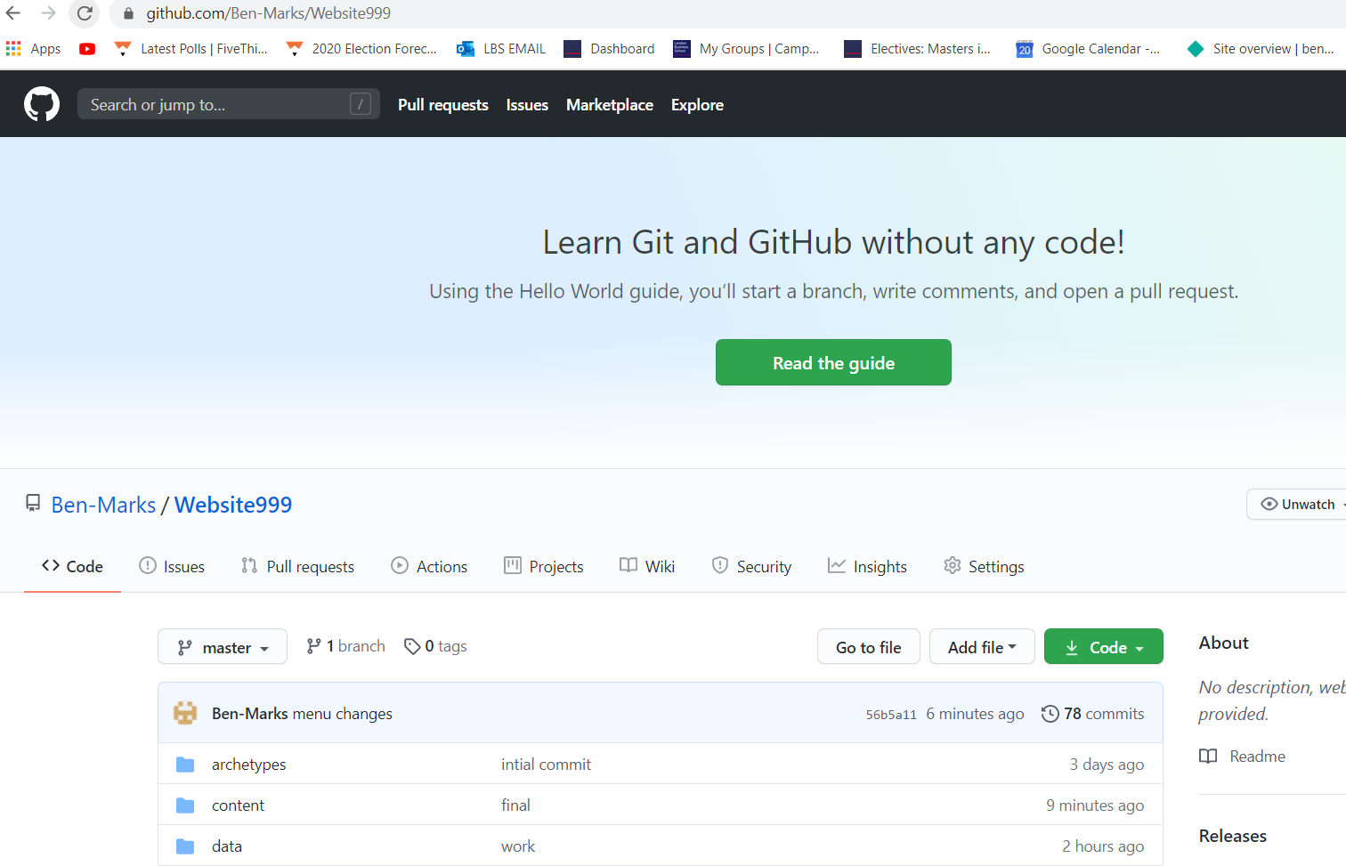

1. Netlify deployments

